LABs Reservation System

# Instructions

* Due date will be on Bb.
* You need to submit GitHub link that shows the code after editing
* Issues email me [mmbasher@kku.edu.sa](mailto:mmbasher@kku.edu.sa)

# Questions

1. Install the project code from <https://github.com/MohammadAlasmary/ReservationSystem/>
2. If you know how to import it using Eclipse, go to step.6
3. Create a new Java project with any name using Eclipse
4. Inside the project, create a package with name sem451
5. Copy all the java files from …\RoomReserve.zip\Room Reservation\src\sem451\ to the created package to be as the first image
6. Try to run the code several times and study its issues
7. Try to understand the project with help of class diagrams
8. Fix the code to handle any errors might happen from the user during writing date, time, or age.
9. Implements at least one method from OptionalReserveTasks inside KkuSystem class
10. Create a separate class for ReserveBlockList as people for Person class to manage all of its functions
11. When you are done, fork and upload your code on your GitHub account and submit the link.

**Answer:**

**5 – make all classes in package and screen shot for this :**

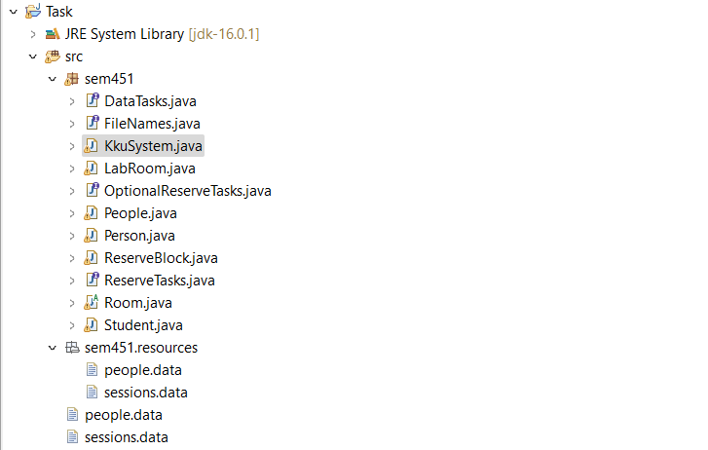

**6 – run code and output:**

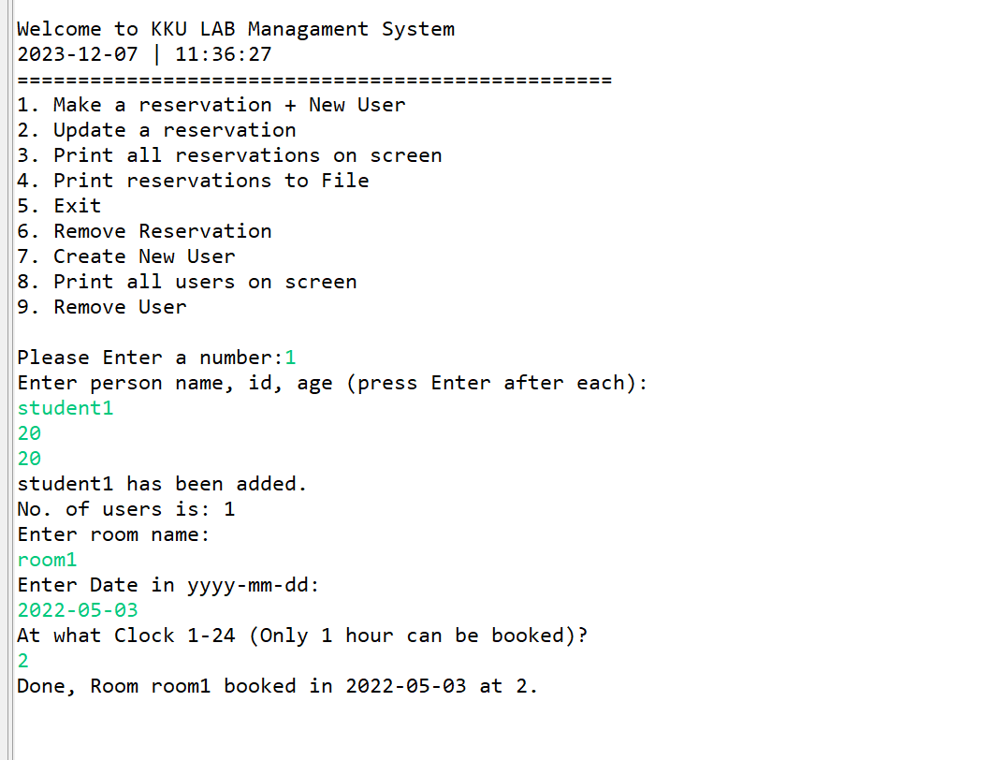

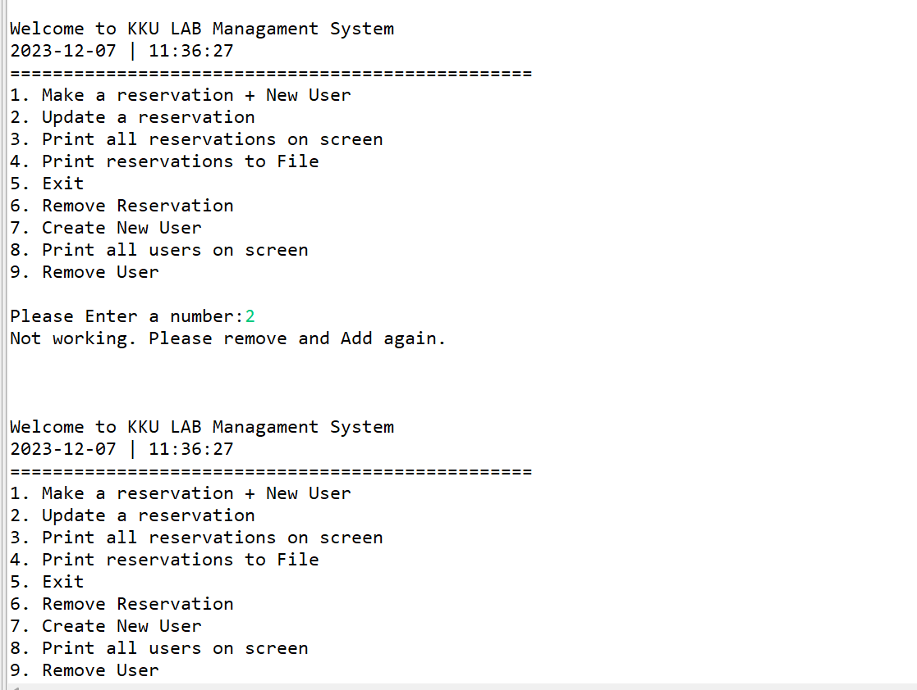

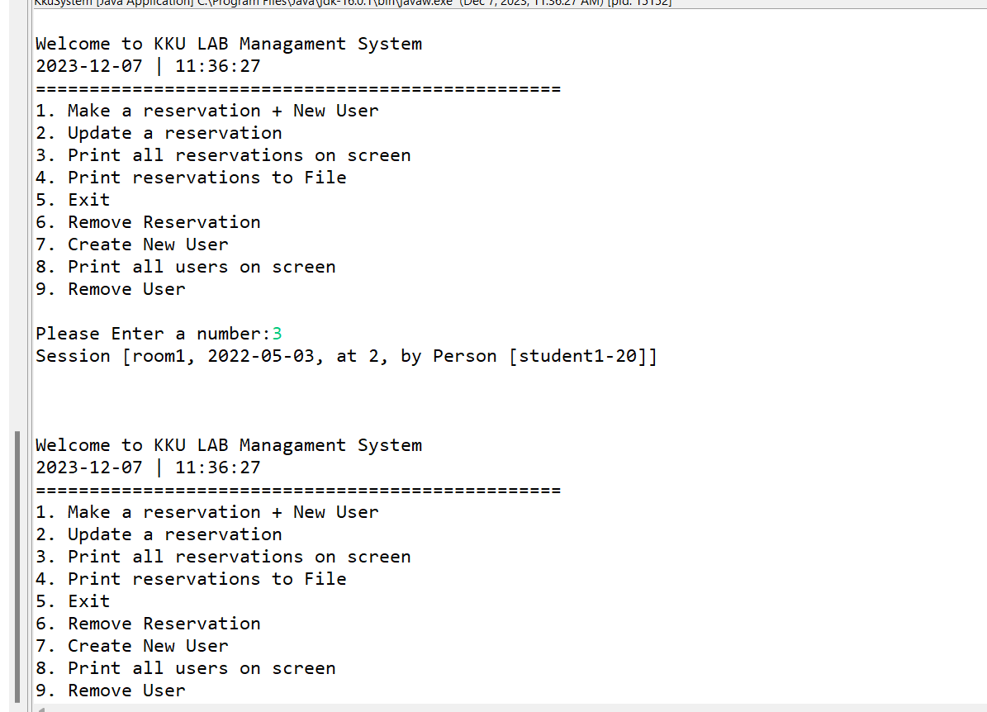

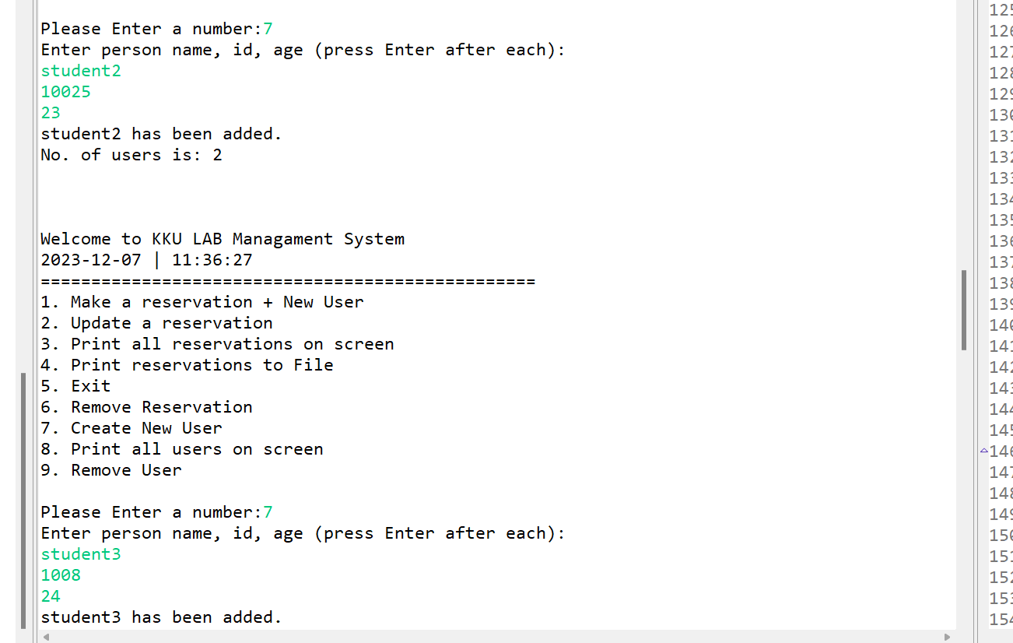

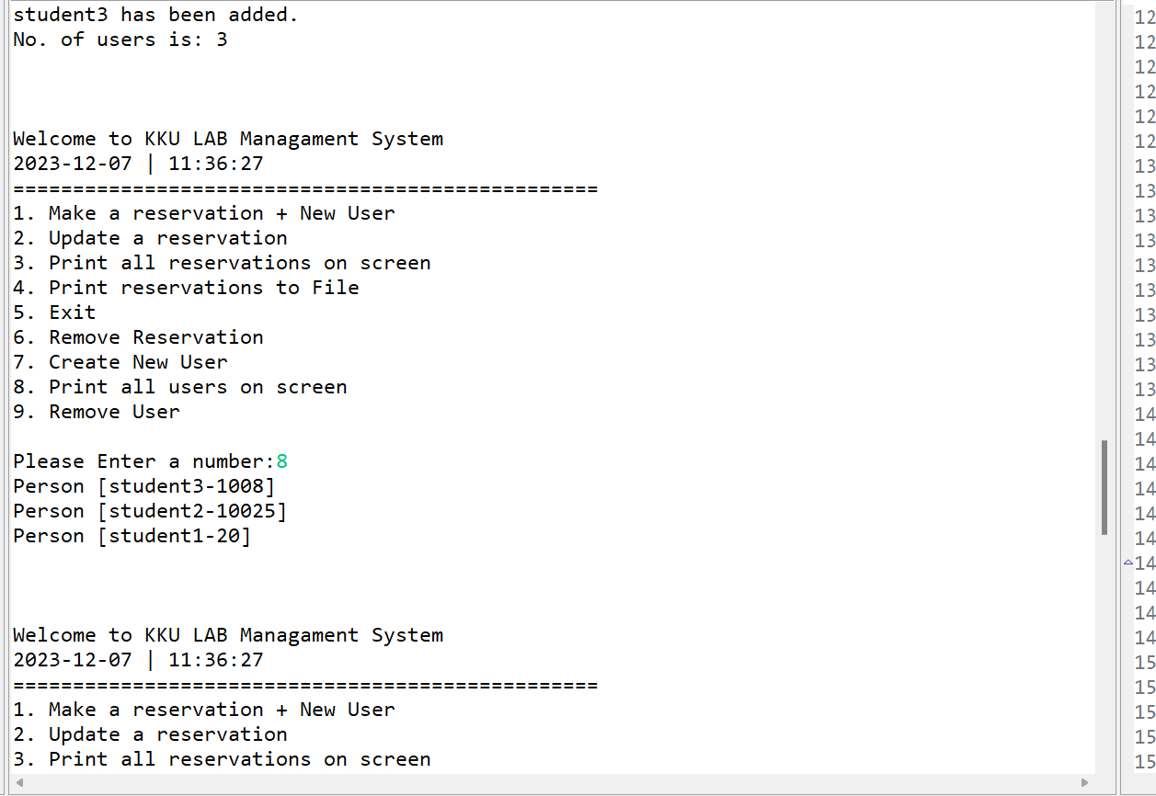

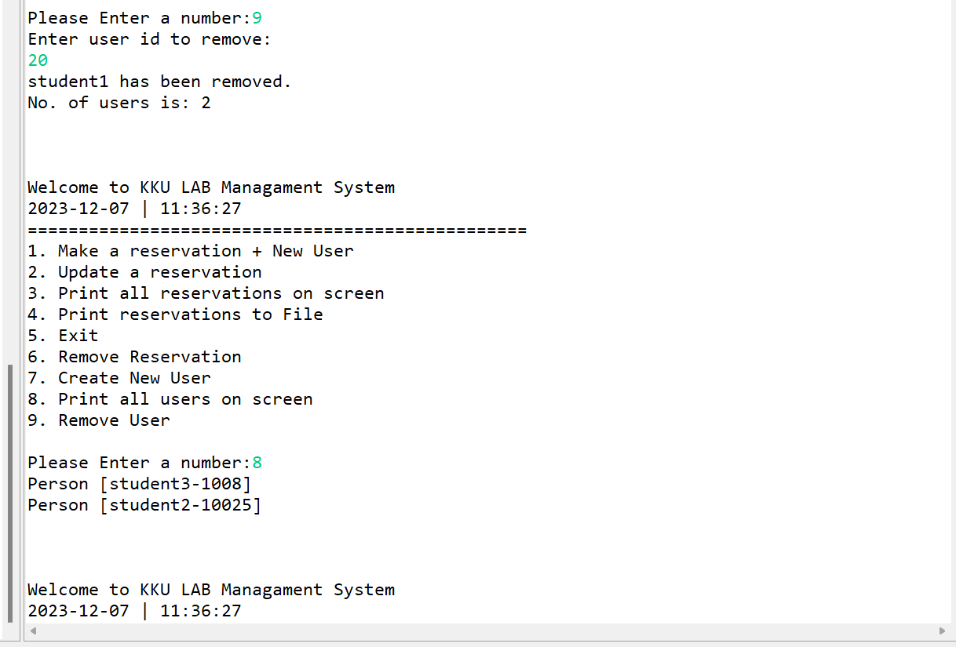

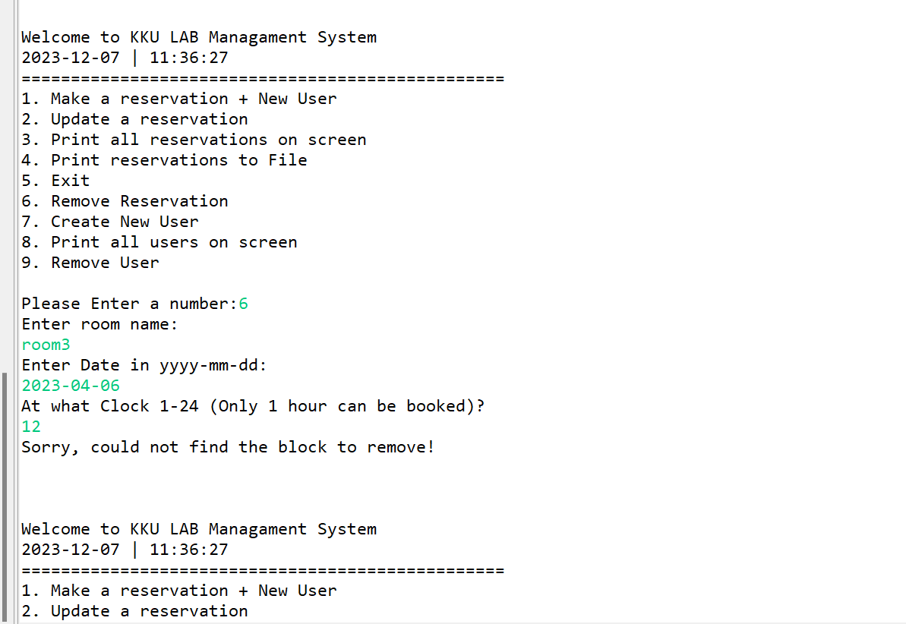

9-



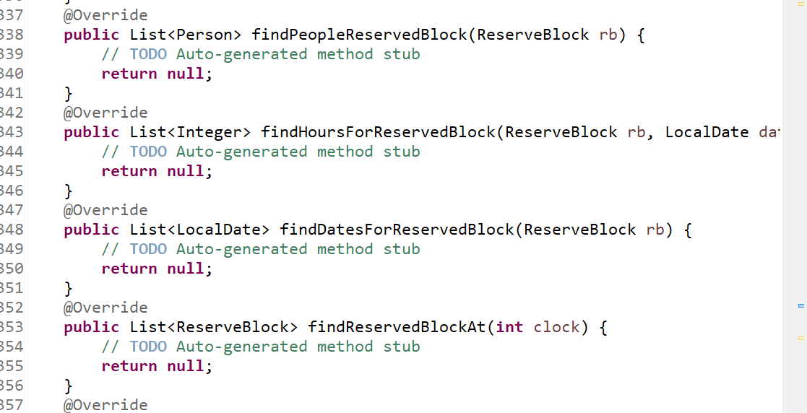

10-

**package** sem451;

**import** java.util.List;

**import** java.util.ArrayList;

**public** **class** ReserveBlockList{

**private** List<Person> blockedPeople;

**public** ReserveBlockList() {

blockedPeople = **new** ArrayList<>();

}

**public** **void** addBlockedPerson(Person p) {

blockedPeople.add(p);

}

**public** **void** removeBlockedPerson(Person p) {

blockedPeople.remove(p);

}

**public** **boolean** isBlocked(Person p) {

**return** blockedPeople.contains(p);

}

}

